

Practical Report

For IoT Practical



January 1, 2022

Darshan Ramjiyani (DSP)

DOCS, KSKV Kachchh University

* **4.4 Serial Communication – Send Multiple text field in one message**
* **Arduino Code:**

int baudRate = 9600;

void setup()

{

  /* Established Serial Communication. */

  Serial.begin(baudRate);

  Serial.println("Connection Establishing connection...!");

  while(!Serial){}

  Serial.println("Connection Established!");

  /* Wait until Serial Communication not established. */

  while(!Serial){}

  /* Send data through Serial Communication. */

  Serial.println("- Name of Author : DSP -");

  Serial.println("---------------------------------------------------------");

}

void loop()

{

 int value1 = 10; // some hardcoded values to send

 int value2 = 100;

 int value3 = 1000;

 Serial.print('H'); // unique header to identify start of message

 Serial.print(",");

 Serial.print(value1,DEC);

 Serial.print(",");

 Serial.print(value2,DEC);

 Serial.print(",");

 Serial.print(value3,DEC);

 Serial.print(","); // note that a comma is sent after the last field

 Serial.println(); // send a cr/lf (End of message)

 delay(100);

}

* **Processing Code:**

import processing.serial.*;

Serial myPort;

char HEADER = 'H';

short LF = 10;

short portIndex = 3;

void setup()

{

    size(200, 200);

    println(Serial.list());

    println(" Connecting to -> " + Serial.list()[portIndex]);

    myPort = new Serial(this,Serial.list()[portIndex], 9600);

}

void draw() {}

void serialEvent(Serial p)

{

    String message = myPort.readStringUntil(LF);

    if(message != null)

    {

        print(message);

        String [] data = message.split(",");

        if(data[0].charAt(0) == HEADER && data.length > 3)

        {

            for( int i = 1; i < data.length-1; i++)

            {

                println("Value " + i + " = " + data[i]);

            }

            println();

        }

    }

}

* 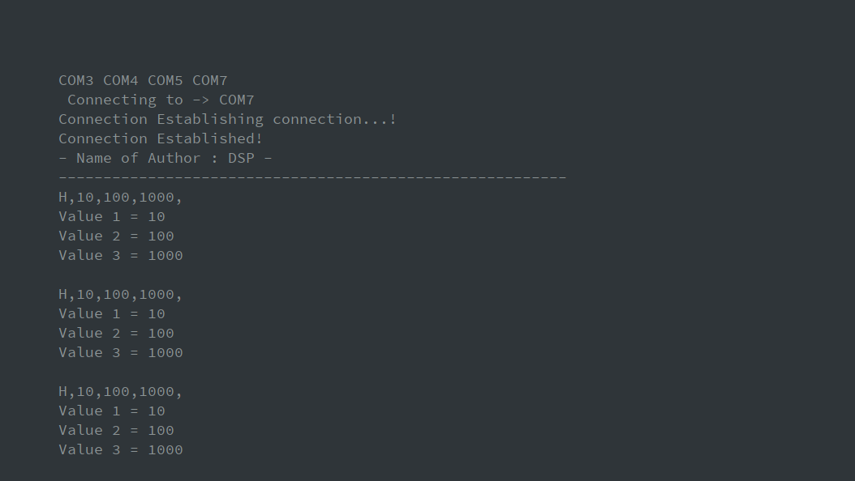Output:

Output From Dwaidh Terminal